**HTML Basics**

**Overview**

This project is the first step in the creation of an art store website. Your task is to create an HTML page from scratch based on the image in Figure 1.

**Instructions**

1. Open project03.html file in the editor of your choice, and open it in a browser.
2. Add markup and content, making best guesses as to what HTML markup to use.
3. Remember to try and get in the habit of using semantic markup, since it adds meaning and has no visual impact.

**Test**

1. Display your page in a browser, and determine if it looks like Figure 1.
2. Validate the page by pasting the HTML into <http://validator.w3.org/> and seeing if it passes.

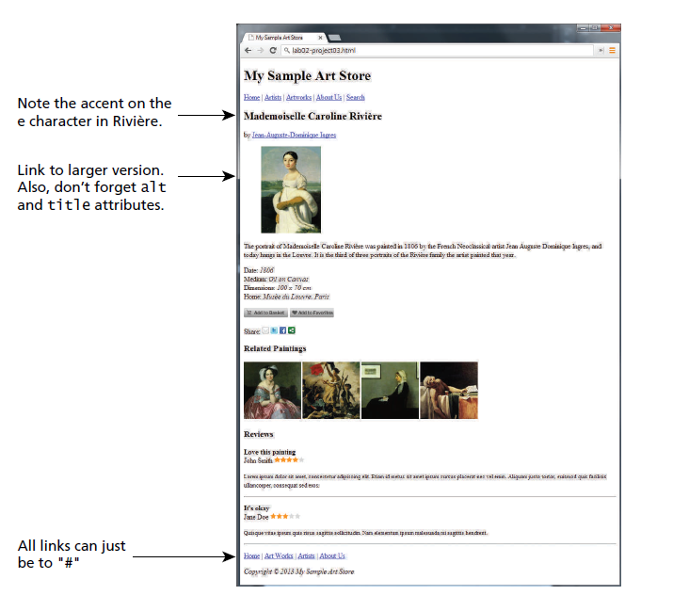

Figure Completed Answer

1. **Text is not clear**
2. **Is it ok to use style tag for margin and float?**